Zabbix Server Health Check

The Documentation of creating Zabbix server health check and sending the data through the telegram.

The references:
Zabbix server external check configuration

Resolving The information type trigger automatically in Zabbix

The start point is writing a bash script to give data from the server that Zabbix is running on it, the example script looks like this:
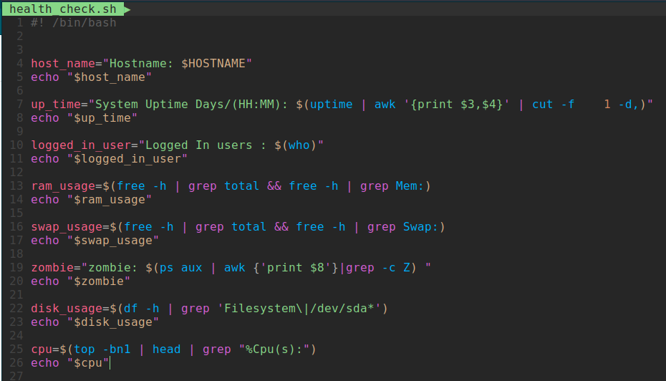

Note: You should put the script in Zabbix external scripts path(you can find yours in zabbix_server.conf file), but usually it is /usr/lib/zabbix/externalscripts.

Next step is creating an item in Zabbix in your desired host, The example item looks like this:
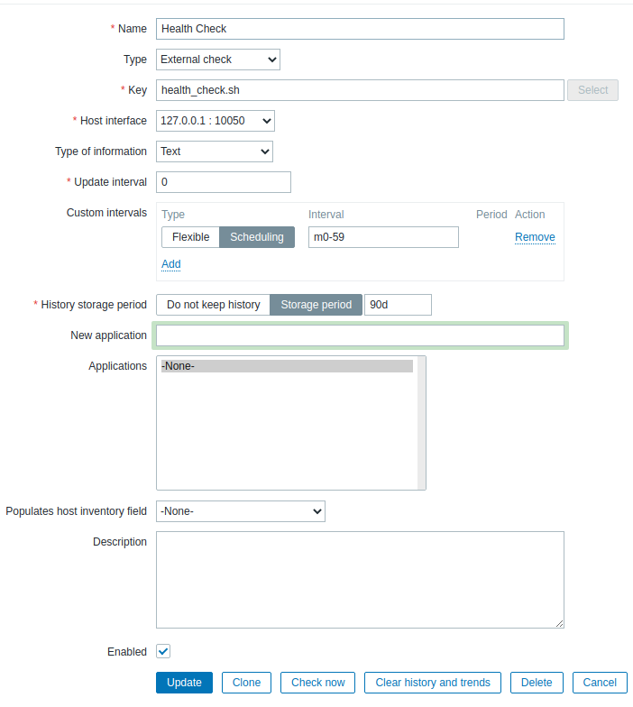
Note: The type of item must be external check so you can use your script.
Note: Type of information must be Text.
Note: set your custom interval based on your needs.
For more information About custom intervals visit:
--- Zabbix custom intervals documentation.
Next step is configuring a trigger for the item we created, the example trigger looks like this:
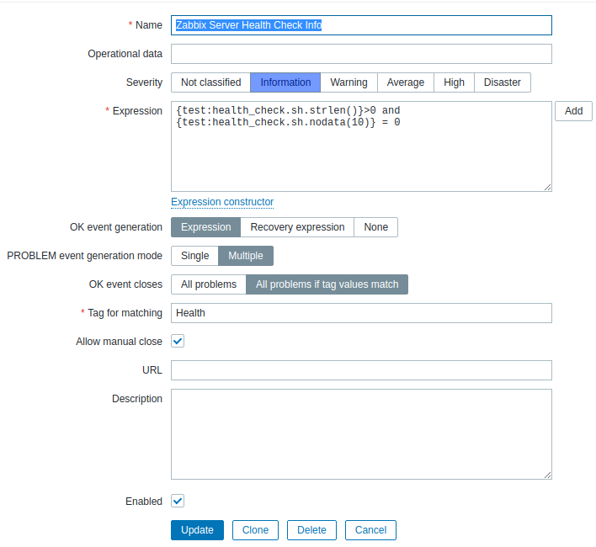
Note: The used expression in picture checks that the given data’s length is not 0 and then use the nodata() function to resolve the trigger automatically after 10 seconds that the trigger runs to PROBLEM state.

Note: Problem event generation mode should be set to Multiple, so we can generate multiple triggers even if the last triggers are not resolved(for short time repetitive triggers.)

Note: you can enable manual close if you want to be able to close the trigger your self and not automatically.

The next Step is configuring an action to send the data to a media that you want to send your health check through it. Example media looks like this:
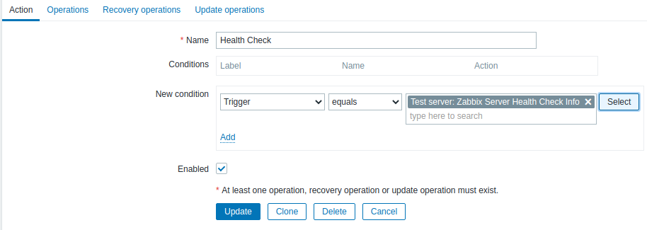
And the operation:
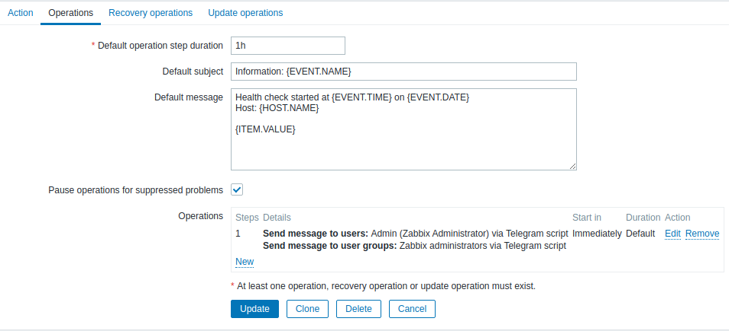

Note: Because the trigger type is INFORMATION there is no need for a recovery operation.

Note: You can send the message to your defined media.

For creating a Telegram Media Type you can use these docs:

The Github Repo of building telegram media in Zabbix.

My guide to how to set up the telegram media in Zabbix based on Zabbix in telegram GitHub repository

